The Menstrual Cycle

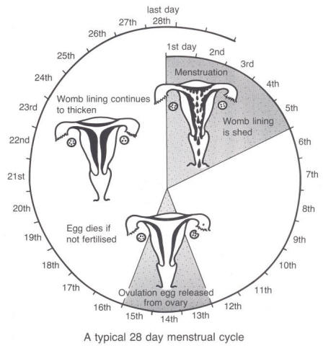

Questions – answer in sentences in your book
- Which part of the body produces FSH?
- What does FSH stand for?
- What does FSH do?
- What produces oestrogen?
- What does oestrogen do?

