

S1 Learning Log

Name: __________________________________

Teacher: _________________________________

Class: ­­­­­­­

____________

Expectations

It is important that you are part of the class at all times and therefore you will be expected to change into PE kit for each lesson. If you are injured or ill, please speak to your teacher after getting changed where you will be given a suitable task. This may include; referee, scorer, feeder or minor performing role. You will never be given a task that will make your injury worse. There is something for everyone in PE.

Indoor Kit

* Plain white t-shirt
* Black bottoms (shorts, leggings or tracksuit bottoms)
* Trainers

Outdoor Kit

* Plain white t-shirt
* Black bottoms (shorts, leggings or tracksuit bottoms)
* Outdoor trainers
* Jumper

*If you forget any part of your kit, go straight to your teacher before entering the changing room.*

Behaviour + Attitude

As soon as you arrive in the Physical Education department we expect the following from you;

* Arrive on time
* Get changed quickly
* Wait patiently in the area your teacher has identified
* Work to the best of your ability throughout the whole lesson

Health and Wellbeing

Experience and Outcomes

It will enable you to develop the concepts and skills necessary for participation in a wide range of physical activity, sport, dance and outdoor learning, and enhances your physical wellbeing in preparation for leading a fulfilling, active and healthy lifestyle.

You will:

* Experience a variety of activities
* Work independently and with others
* Use different equipment
* Work indoors and outdoors
* Improve your physical, social, mental and emotional qualities
* BE CHALLENGED

Physical Education will provide you with a platform from which you can build physical competences, improve aspects of fitness, and develop personal and interpersonal skills and attributes.

MOVEMENT SKILLS, COMPETENCIES AND CONCEPTS:

As I encounter new challenges and contexts for learning, I am encouraged and supported to demonstrate my ability to select, adapt and apply movement skills and strategies, creatively, accurately and with control. **HWB 3-21a**

As I encounter a variety of challenges and contexts for learning, I am encouraged and supported to demonstrate my ability to select and apply a wide range of complex movement skills and strategies, creatively, accurately and with consistency and control. **HWB 4-21a**

I practise, consolidate and refine my skills to improve my performance. I am developing and sustaining my levels of fitness. **HWB 3-22a**

I can organise my time to practise, consolidate and refine my skills to achieve my highest quality performance in a range of contexts. I am developing and sustaining my level of performance across all aspects of fitness. **HWB 4-22a**

COOPERATION AND COMPETITION

I am developing the skills to lead and recognise strengths of group members, including myself. I contribute to groups and teams through my knowledge of individual strengths, group tactics, and strategies. **HWB 3-23a**

While learning together, and in leadership situations, I can:

* experience different roles and take responsibility in organising a physical event
* contribute to a supportive and inclusive environment
* demonstrate behaviour that contributes to fair play. **HWB 4-23a**

EVALUATING AND APPRECIATING

I can analyse and discuss elements of my own and others’ work, recognising strengths and identifying areas where improvements can be made. **HWB 3-24a**

I can:

* observe closely, reflect, describe and analyse key aspects of my own and others’ performances

• make informed judgements, specific to an activity

• monitor and take responsibility for improving my own performance based on recognition of personal strengths and development needs. **HWB 4-24a**

S1 Curriculum

Activities

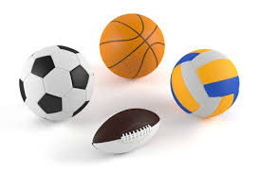

Team Games

* Basketball
* Softball
* Hockey
* Football
* Rugby

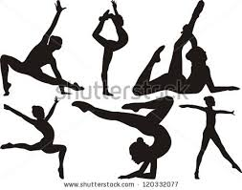

Aesthetic Activities

* Dance
* Gymnastics

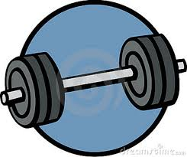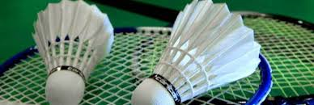

Health & Fitness

* Fitness Suite
* Circuits
* Royal Stuart Mile
* Exercise to Music

Individual Activities

* Badminton
* Table Tennis

Athletics

Personal Record

|  |  |
| --- | --- |
| EVENT | RESULT |
| Royal Stuart Mile |  |
| 60 metre sprint |  |
| Long Jump |  |
| Shot Putt |  |
| Javelin |  |
| Discuss |  |

Can you complete the following table to identify the *current world records* for each of these events:

|  |  |  |
| --- | --- | --- |
| EVENT | WORLD RECORD | |
|  | Name | Result |
| 1500 metres |  |  |
| 100 metre sprint |  |  |
| Long Jump |  |  |
| Shot Putt |  |  |
| Javelin |  |  |
| Discuss |  |  |

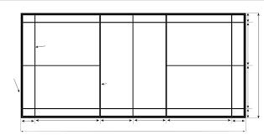Badminton Scatter Diagram

Stroke played:

______________

Stroke played:

______________

Stroke played:

______________

Team Games

Through a variety of team games you will experience this year, you will develop your movement skills.

Below is a list of team activities, can you link the correct skills to the correct activities?

Draw a line to connect the skills to their activity.

(Some may be linked to more than one activity).

Basketball Softball Hockey Football Rugby

Shooting

Passing

Dribbling

Striking

Catching

Throwing

Running

Jumping

Tackling

Defending

Attacking

Fitness

Can you match the following aspects of fitness with the correct definition?

A combination of speed and strength

Cardiorespiratory Endurance (CRE)

The range of movement across a joint

Muscular Endurance (ME)

The maximum amount of force a muscle or group of muscles can exert in a single effort

Speed

The ability of the heart and lungs to provide oxygen to the working muscles over a long period of time without tiring.

Strength

Flexibility

The ability to move the whole body or part of the body quickly in a short period of time

Power

The ability of muscles to work for a long period of time without tiring.

|  |  |  |  |  |
| --- | --- | --- | --- | --- |
| Aspect of Fitness | Test | Baseline Results | Re-test 1 | Re-test 2 |
| CRE | Bleep Test |  |  |  |
| 12 minute Cooper Run |  |  |  |
| ME | Press Up Test |  |  |  |
| Sit Up Test |  |  |  |
| POWER | Vertical Jump |  |  |  |
| Standing Broad Jump |  |  |  |
| FLEXIBILITY | Sit and Reach Test |  |  |  |

My Fitness Results

My Fitness Blog

Complete the following fitness blog, creating a diary of any Physical Activity you complete over the course of a week.

|  |  |  |  |
| --- | --- | --- | --- |
| Day | Exercise | Duration | How did this make you feel? |
|  |  |  |  |
|  |  |  |  |
|  |  |  |  |
|  |  |  |  |
|  |  |  |  |
|  |  |  |  |
|  |  |  |  |

My CRE Programme

|  |  |  |  |  |  |
| --- | --- | --- | --- | --- | --- |
|  | Treadmill | Bike | Cross-trainer | Rowing machine | Skipping |
| Session 1 |  |  |  |  |  |
| Session 2 |  |  |  |  |  |
| Session 3 |  |  |  |  |  |
| Session 4 |  |  |  |  |  |
| Session 5 |  |  |  |  |  |
| Session 6 |  |  |  |  |  |
| Session 7 |  |  |  |  |  |
| Session 8 |  |  |  |  |  |
| Session 9 |  |  |  |  |  |
| Session 10 |  |  |  |  |  |

Each time you are in the fitness suite, keep a record of your session writing down the following:

* The time spent on each piece of equipment
* The level you worked at

(E.g. Treadmill, 5 minutes, level 10).

Aesthetics

Use the following table to evaluate an aesthetic performance. Record the number of times the elements are used.

|  |  |
| --- | --- |
| Aesthetic elements | Record |
| Canon |  |
| Formation |  |
| Unison |  |
| Levels |  |
| Direction |  |
| Speed |  |
| Creativity |  |

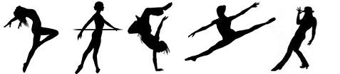

Aesthetic Sequence

Use the following tables to record the aesthetic sequences that you create.

Sequence 1:

Sequence 2:

Sequence 3:

Gymnastics Skills Bank

|  |  |
| --- | --- |
| BALNCE | FLIGHT |
| ROTATION | INVERSION |

Cooperation and competition

|  |  |
| --- | --- |
| Roles | Personal qualities needed to fulfil these roles |
| Performer |  |
| Team mate |  |
| Referee |  |
| Captain |  |
| Coach |  |
| Manager |  |
| Opponent |  |
| Observer |  |

Personal Qualities

Below is a list of personal qualities which are required for different roles in sport.

*Can you give an example of when you might need to show the following during PE or any sport you do out of school?*

|  |  |
| --- | --- |
| Personal Qualities | Example |
| Honesty |  |
| Communication |  |
| Listening |  |
| Positive |  |
| Understanding |  |
| Leader |  |
| Contribute ideas |  |
| Respect |  |
| Effort |  |
| Responsibilities |  |

Peer Assessment

During a game of your choice, ask one of your peers to observe you throughout your performance. They should identify two stars and one wish of your performance focusing on how you worked with others.

Peer Assessment 1:



Peer Assessment 2: